LOST
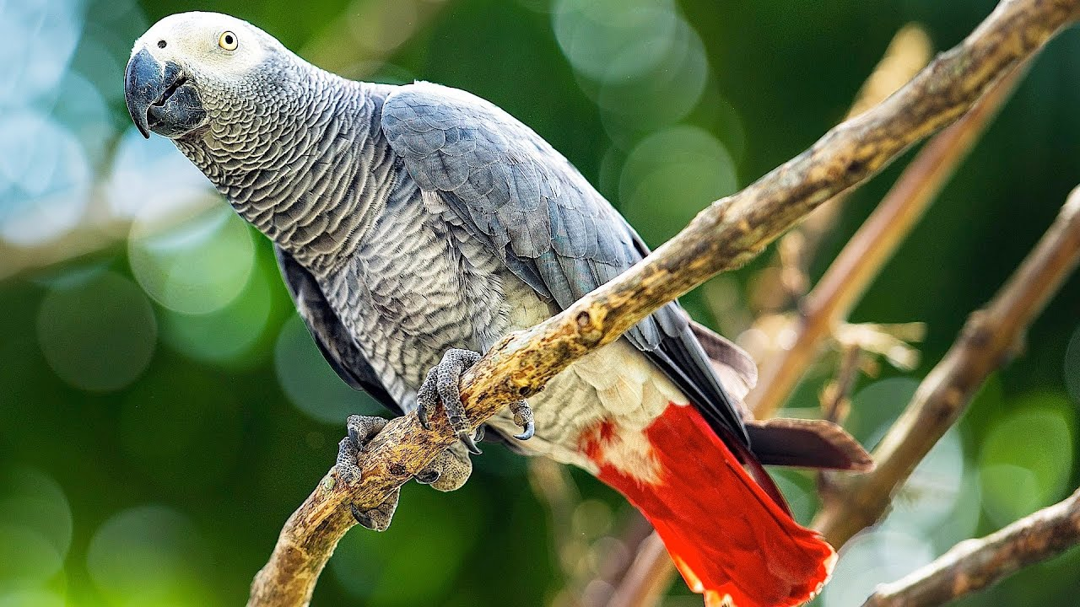
LOST AFRICAN GREY PARROT
We have sadly lost our beautiful family member Dolce.
- Last seen in Craigburn Farm.
- She is mostly grey with a bright red tail.
- She is friendly & does not bite.
- If you spot Dolce please call Dani immediately on
0421 286 279
REWARD OFFERED

