100 Coins Term 4, week 2 Homework

The Middle School teachers have exactly 100 coins saved up. Within these, there are five different values of coins.

We have decided to use the money to buy some resources that total $39.75. We have exactly the correct money - not one cent more, not one cent less!

Can you work out what the five different types of coins are worth and how many of each we have saved?

This is an open-ended problem and there are many different solutions to it. Remember to show us all of your thinking and working out.

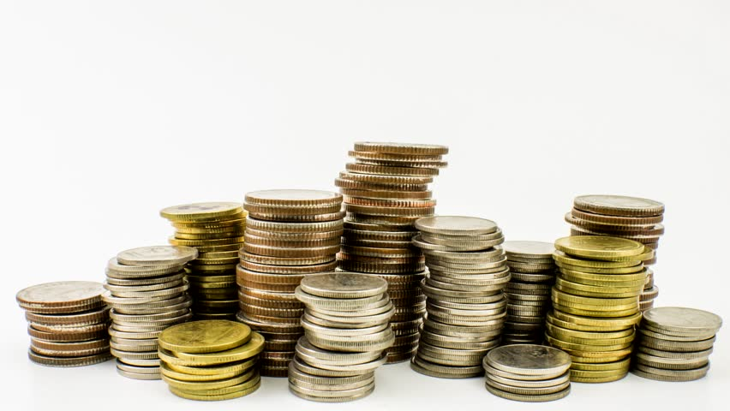
W.A.L.T.
- Solve problem - based problems
- Use decimals within everyday situations
- Use different strategies to tackle math problems
- Clearly show our mathematical thinking

W.I.L.F.
- Effort being put into finding a solution ☐
- Clearly written mathematical thinking ☐
- Accuracy in decimal calculations ☐
- Final solution presented (if found) ☐

100 Coins Term 4, week 2 Homework

The Middle School teachers have exactly 100 coins saved up. Within these, there are five different values of coins.

We have decided to use the money to buy some resources that total $39.75. We have exactly the correct money - not one cent more, not one cent less!

Can you work out what the five different types of coins are worth and how many of each we have saved?

This is an open-ended problem and there are many different solutions to it. Remember to show us all of your thinking and working out.

W.A.L.T.
- Solve problem - based problems
- Use decimals within everyday situations
- Use different strategies to tackle math problems
- Clearly show our mathematical thinking

W.I.L.F.
- Effort being put into finding a solution ☐
- Clearly written mathematical thinking ☐
- Accuracy in decimal calculations ☐
- Final solution presented (if found) ☐

Solution 1:
20 * $1.00 | = | $20.00
20 * 50c | = | $10.00
44 * 20c | = | $8.80
3 * 10c | = | 30c
13 * 5c | = | 65c
Total |  | $39.75
Solution 2:
7 * $1.00 | = | $7.00
48 * 50c | = | $24.00
43 * 20c | = | $8.60
1 * 10c | = | $0.10
1 * 5c | = | $0.05
Total |  | $39.75
Solution 3:
10 * $1.00 | = | $10.00
50 * 50c | = | $25.00
10 * 20c | = | $2.00
25 * 10c | = | $2.50
5 * 5c | = | 25c
Total |  | $39.75

Solution 4:
1 * $1.00 | = | $1.00
72 * 50c | = | $36.00
8 * 20c | = | $1.60
4 * 10c | = | 40c
15 * 5c | = | 75c
Total |  | $39.75

