



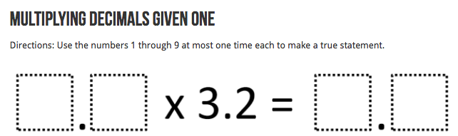

**Homework Week 4 Term 4 – Number Problems**

Find at least **two** solutions for each of these problems.

For each problem you cannot repeat a number in the same solution.

Show your working out.

Be prepared to share your strategies.

