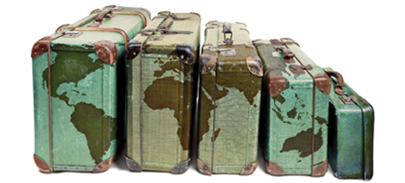
Where do you come from?

Your task this week is to talk to your family about where your family comes from. Where were your parents born? Where were your grandparents born? Where were your great –grandparents from? How far back can you go? Can you find a family member that was born in a different country and moved to Australia? Do you know why and when they relocated?

From the notes that you take when talking to your family, show your families history in a creative way. Make sure you indicate these places on the given world map.

WALT | Taking notes | ☐
 | Analyse and Interpret family history | ☐
WILF | Clear and detailed notes | ☐
 | Evidence of planning | ☐
 | Creative and thoughtful presentation | ☐

Where do you come from?

Your task this week is to talk to your family about where your family comes from. Where were your parents born? Where were your grandparents born? Where were your great –grandparents from? How far back can you go? Can you find a family member that was born in a different country and moved to Australia? Do you know why and when they relocated?

From the notes that you take when talking to your family, show your families history in a creative way. Make sure you indicate these places on the given world map.

WALT | Taking notes | ☐
 | Analyse and Interpret family history | ☐
WILF | Clear and detailed notes | ☐
 | Evidence of planning | ☐
 | Creative and thoughtful presentation | ☐

