Data and Statistics Homework – week 7, term 3

Choose three of these open-ended problem solving activities to complete. Some are trickier than others!
Remember to show us all of your thinking and extend you learning by trying your best.

Imagine you are selecting coloured cubes out of a bag. What colours of cubes, and how many of each colour, might be in the bag if the probability of pulling out a green one is close to 1/3?
Describe an event that fits each word:

Impossible Certain

Unlikely

Probable

You roll two dice. Is it more likely that the sum is 8 or that the difference is 2?

Think about using a table or chart to show all of your working out.
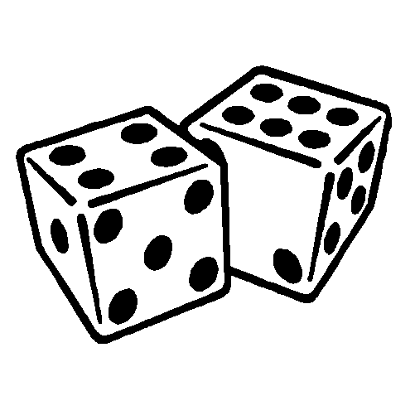

Create a set of data where the mean is greater than the median.
Describe a situation where you might conduct an experiment in order to gather some data.
Why would an experiment make sense in that situation?
Sort the numbers from 1 to 20 by using two sorting rules so that there are four numbers in each overlap (they fall in both categories).

